Farhad Ahmed

Computer Networking

10/25/18

**Lab – UDP Pinger**

*Running ifconfig:*

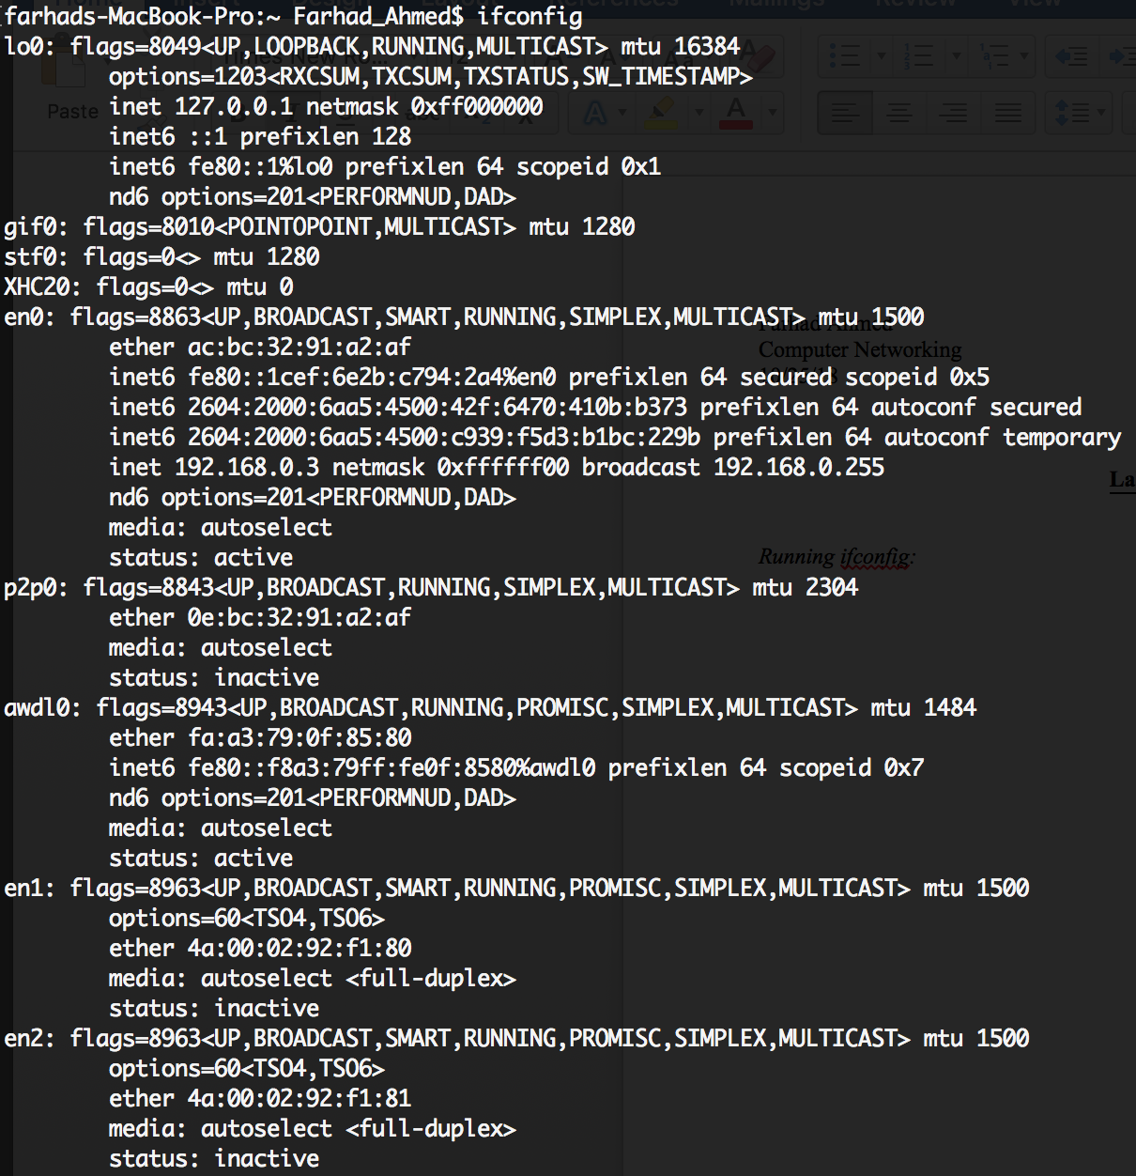

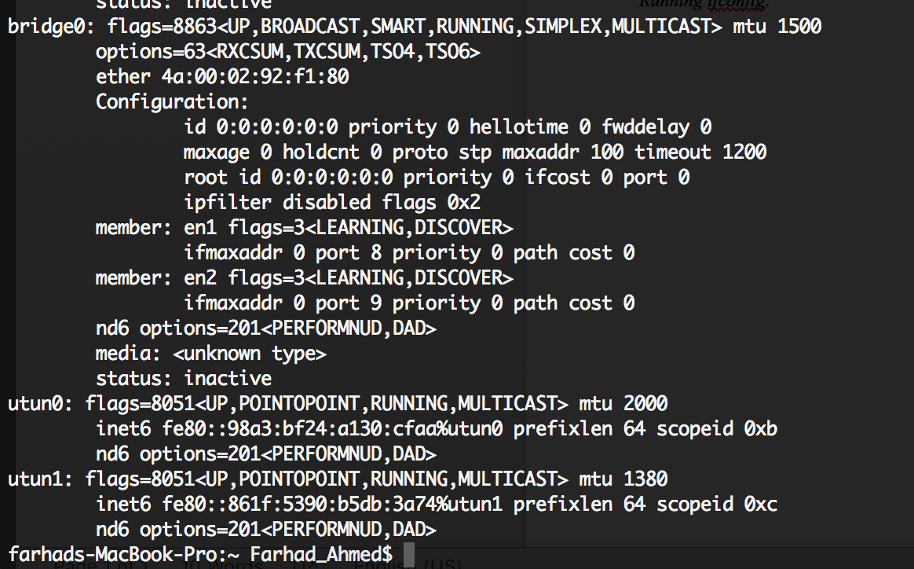

*Screenshot of UDP Server and Client Running Simulaneously:  
